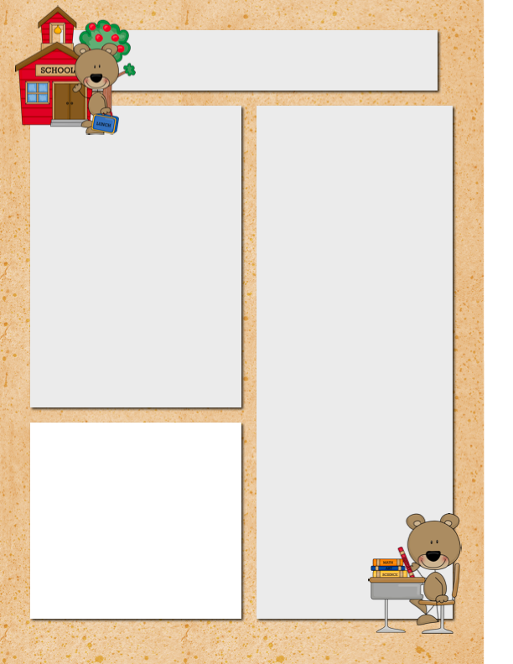



**Dates to Remember**

●September 4 No School, Labor Day

●September 12 DIBELS Testing, Grade 2

●September 18 Open House 6:00-8:00

Mrs. Beers Weekly Newsletter

***September 4 – 8, 2017***

**Unit 1 Week 1**

**Spelling Words**

●has

●wag

●bad

●six

●will

●sat

●had

●fix

●him

●if

●can

●hit

●why

●for

●help

**Vocabulary Words**

●actions

●afraid

●depend

●nervously

●peered

●perfectly

●rescue

●secret

**High Frequency Words**

blue, even, yellow, help, put, for, ball, there, both, why

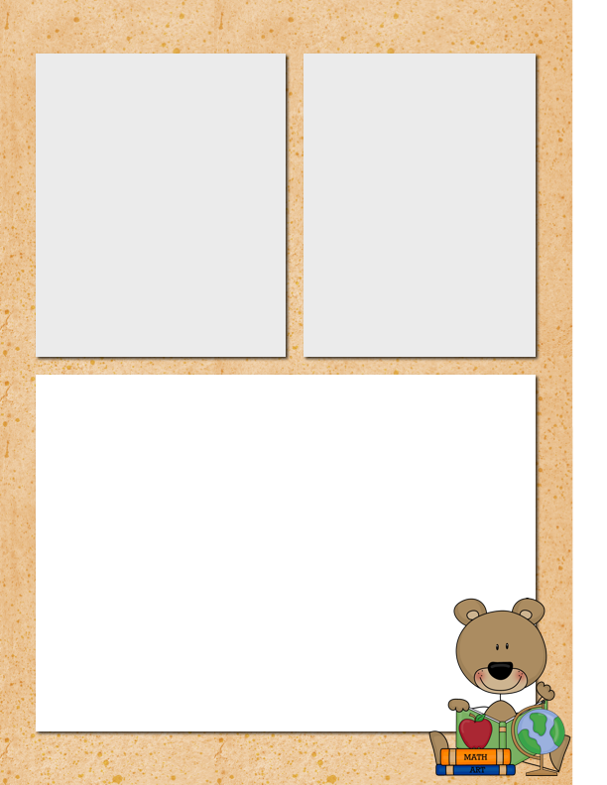

**Special Area Classes:**

Monday: No School

Tuesday: Music

Wednesday: Computers

Thursday: Library

Friday: Gym

Dear Parents,

We had a super first day of school. I look forward to working with you and your child to make this a wonderful school year!

Sincerely,

Mrs. Beers

**Homework:**

Monday: No School

Tuesday: Math Worksheet

Wednesday: Math Worksheet

Thursday: Math Worksheet

Friday: No Homework!

**What Skills Are We Working On?**

●**Language Arts**:

Essential Question: How do friends depend on each other?

Word Work: Short a/I, Plural Nouns (-s, -es)

Comprehension: Visualize, Key Details

Genre: Fantasy

Writing: Kid Writing

Grammar: Statements and Questions

●**Math**: We will problem solve to find the sum or difference. We will also use strategies to count on.

●**Printing**: We will practice writing the lowercase letters using slant print.

●**Science/Social Studies**: We will begin our butterfly unit.